|  |
| --- |
| **Punchh Integration Setup Instructions**  **for**  **MICROS** |

Table of Contents

1. Introduction 3

2. Prerequisites 3

3. Parameter Verification in the MICROS application 4

3.1. The IDNPrinter parameter 4

3.2. The DiscountId parameter 5

3.3. The Interface parameter 8

4. Setup Using the **Punchh Configurator** utility 9

4.1. Setup Parameters on the *punchh.cfg* Screen 9

4.1.1. Update the value for the API_Key parameter: 9

4.1.2. Update the LogLevel parameter 10

4.1.3. Update the POS_Type parameter: 10

4.2. Setup Parameters on the *Micros.cfg* Screen 10

4.2.1. Update the DiscountId Parameter 11

4.2.2. Update the IDNPrinter parameter 11

4.2.3. Update the Interface parameter 11

4.2.4. Update the PathToMicros parameter 11

4.2.5. Update the Port parameter 11

4.2.6. Apply the Parameter Changes 11

4.3. Verify the Punchh Service setup 11

5. Micros Application Integration with Punchh Service 14

5.1. Micros Application Setup 14

5.2. Micros Application Configuration 14

5.2.1. Login into the POS Configurator application: 14

5.2.2. Setup the Punchh interface record 15

5.2.3. Verify Discounts 16

5.2.4. Setup Check Trailer on RVC Print Design 17

5.2.5. Create the Touchscreen button 18

5.2.6. Reload the MICROS DB (or Reboot the system) 19

# Introduction

Punchh **Point of Sales** (**POS**) Integration is done via a proxy web service, which is running on a local network. POS can talk to the service either via HTTP POST calls, direct socket calls, file system, etc. Proxy service forwards calls to the Punchh backend and takes care of logging, heartbeat and queuing the data in case of network outages.

POS Integration is done differently for each POS system, but there is a common component that has to be installed first. That is the **Punchh Integration Service** (PIS).

The required steps for installing the PISon Windows and Lunix are covered by the **Punchh Integration Setup Instructions for Punchh Integration Service** document.

A purpose of this Instruction is to complete the Punchh Integration Setup for the specific POS – **MICROS**.

**\*NOTE**: screenshots below maybe different depending on your version of the POS.

# Prerequisites

|  |
| --- |
| **It is a mandatory to do the Punch Integration Setup and Configuration only during the off hours. Otherwise, terminals will be unavailable for business.** |

1. You must complete the Punchh Integration Service setup according to the “**Punchh Integration Setup Instructions for Punchh Integration Service**” successfully.
2. Verify, that you have the valid “POS Configurator” user name and password which gives you edit access to: Interfaces, Screen Designer, Print Designer, Discounts
3. Find out from the POS owner\operator, where do they want the **Check-in** and **Redeem** buttons to be placed.
4. Verify that your MICROS configuration includes the PMS/SIM license Add-On:

* Navigate to Micros Application -> Utilities -> Micros License Manager -> POS 3700
* Verify that the PMS/SIM parameter is check-marked in green:

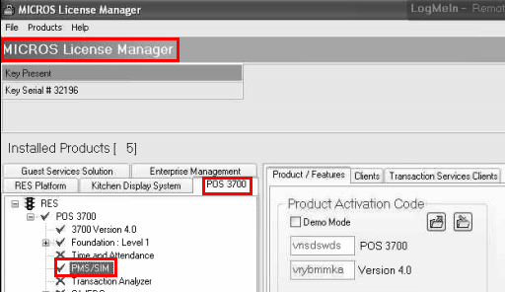

1. Verify if the MICROS Database is up and running.

* Navigate to the **Micros Applications** menu and select the **Micros Control Panel** item:

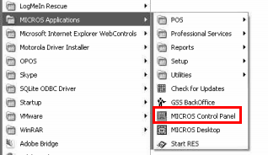 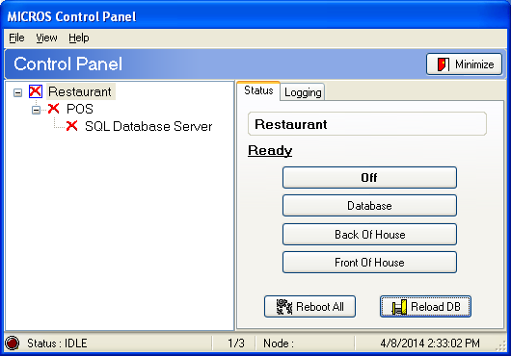

* Hit the **Front Of House** button and hit the **Reload DB** button to get the following status if needed:

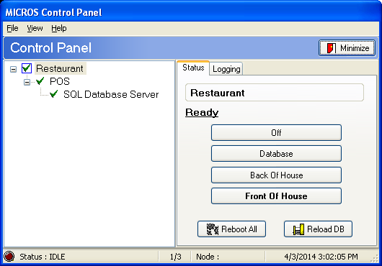

# Parameter Verification in the MICROS application

Login into the **POS Configurator** application:

1. Start the **POS Configurator** application: "C:\Program Files\MICROS\Res\Pos\Bin\poscfg.exe"
2. Login: <Enter Your Login Credential> -> hit Enter

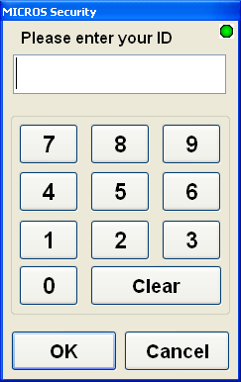

## The IDNPrinter parameter

After updating some parameters on the **punchh.cfg** screen manually via the provided Punchh Configurator utility and starting the Punchh service, the service inserts the default value such as “**False**” for the **IDNPrinter** parameter on the **Micros.cfg** screen (the **Punchh Configurator** utility).

|  |
| --- |
| Punchh supports the printers with the following *Printer Interface Type*:   1. **RS-232 Interface** 2. **IDN Interface**   **It is a mandatory that all printers must be of the same type either RS-232, or IDN, but never both of them on the same network. Otherwise, the Punchh barcode will be printed on the receipts coming out only from the printer selected for the IDNPrinter parameter on the Micros.cfg screen (“TRUE” for the IDN printer, or “FALSE” for the RS-232 printer).** |

1. Navigate to the **Devices** screen: **Devices** tab **-> Devices** button
2. On the **Devices** screen, go to the **Record View** applet
3. On the **Record View** applet find and select any records related to the printer parameter.
   1. If there is one only printer type record (For instance, the *2-Printer* record):

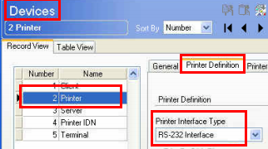

Please write the existing printer type down. You will need to enter the appropriate value for the **IDNPrinter** parameter (“TRUE” for the IDN printer, or “FALSE” for the RS-232 printer) on the **Micros.cfg** screen (the **Punchh Configurator** utility)

* 1. If there is more than one printer type record (For instance, the *2-Printer* and *4-Printer IDN* records)

Per the mandatory requirement mentioned above, a printer must be the only one, either RS-232, or IDN, but never both of them on the same network.

 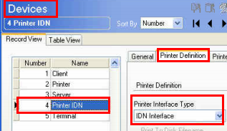

1. Close the **Devices** screen

## The DiscountId parameter

After updating some parameters on the **punchh.cfg** screen manually via the provided Punchh Configurator utility and starting the Punchh service, the service inserts the default value such as “300” for the **DiscountId** parameter on the **Micros.cfg** screen (the **Punchh Configurator** utility). To avoid any conflicts with an existing discount, navigate to the **Discounts** screen and verify the values existing in the **Number** field.

1. Navigate to the **Record View** screen: **Sales** tab **-> Discounts** button:

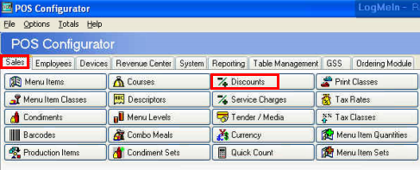

1. On the **Discounts** screen, go to the **Record View** screen, verify the values existing in the **Number** fields, and create a new Punchh discount record:

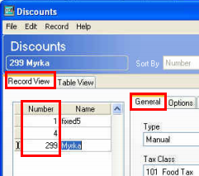

* If the value “**300**” in the **Number** field is NOT associated with any record, then create a new Punchh discount record and put a value “**300**” into the **Number** field
* If the value “**300**” in the **Number** field is associated with any existing discount, then define any other number (for instance, the value such as “**299**”), create a new Punchh discount record, and put a value “**299**” into the **Number** field

**\*NOTE:** You will need to enter your new value for the **DiscountId** parameter on the **Micros.cfg** screen (the **Punchh Configurator** utility)

1. Keep the new **Punchh Discount** record selected, and navigate to the right applet (the **General** tab is selected by default).
2. Verify, that the following parameters in the fields associated with your new Punchh discount record, are up to date, or enter the required values manually as the following:
   1. Navigate to the **General** screen located under the **General** tab:
3. Type: **Manual** (select from drop-down list)
4. NLU = **202**
5. Key Code = **202**

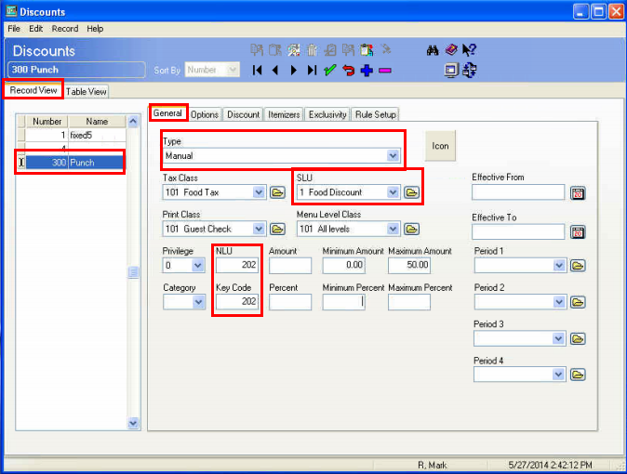

1. Create a new SLU record named “**Punchh Discount**”:

* On the SLU applet, hit the Browse button and navigate to the Descriptors screen
* On the Descriptors screen, create a new SLU record named “**Punchh Discount**”
* Save the “**Punchh Discount**” record and close the **Descriptors** screen:

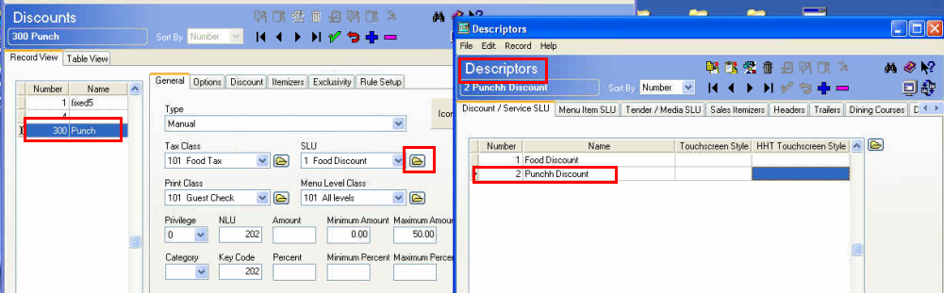

* On the **General** screen, navigate to the SLU field, launch the Pick-List, select there your new Punchh Discount record, and save your changes

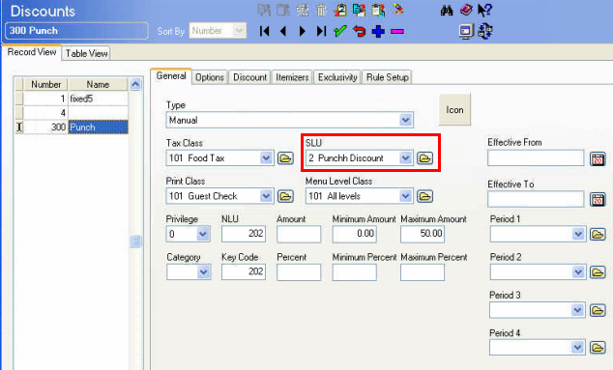

* 1. Navigate to the **Options** applet under the **Options** tab on the right, and select the **Amount** check-box

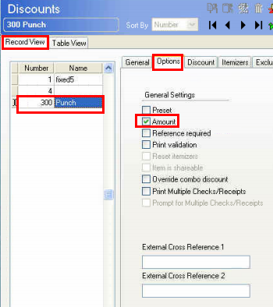

Save your entries - hit the **Save** button located on the Dashboard

* 1. Navigate to the **Itemizers** applet under the **Itemizers** tab on the right, and select at least one Itemizer:

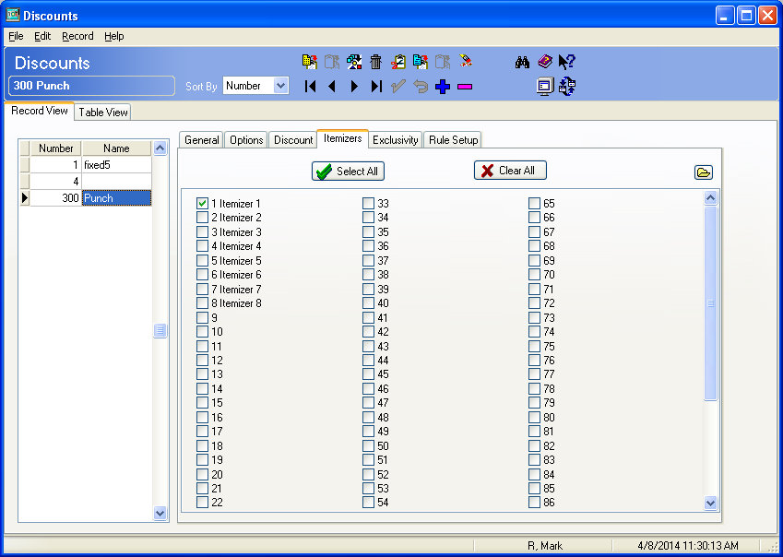

Save your entries - hit the **Save** button located on the Dashboard

1. Close the **Discounts** screen

## The Interface parameter

After updating some parameters on the **punchh.cfg** screen manually via the provided **Punchh Configurator** utility and starting the Punchh service, the Punchh service automatically puts the Punchh’s **pms**XX**.isl** file into some specified directories. By default, the file comes from the Punchh service with the default name such as “**pms90.isl”.** If the Punchh service finds the **pms90.isl** file already existing in any of these directories, then the Punchh service does NOT overwrite the existing **pms90.isl** file (unless that is the Punchh file), and reports such issues into a log file. In a result, the Punchh service cannot function properly.

To avoid this issue, navigate to the **Interfaces** screen and verify if the value “**90**” in the **Number** field is already associated with any existing interface.

1. Navigate to **Devices tab -> Interfaces button**
2. On the **Interfaces** screen, go to the **Record View** screen and verify the values existing in the **Number** fields.

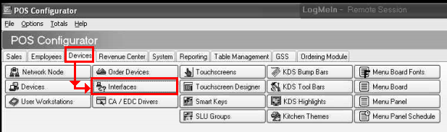 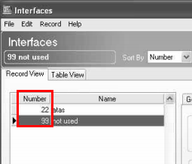

* If the value “**90**” in the **Number** field is NOT associated with any interface, then no actions
* If the value “**90**” in the **Number** field is associated with any interface, then define any other number (for instance, the value such as “**91**”) and write this down. You will need to enter your new value for the **Interface** parameter on the **punchh.cfg** screen (the **Punchh Configurator** utility)

1. Close the **POS Configurator** application.

# Setup Using the **Punchh Configurator** utility

Launch the provided **Punchh Configurator** utility:

|  |
| --- |
| "C:\Program Files\Punchh\Config\PunchhConfigurator.exe" |

The Punchh Configurator screen should pop up, and by default, you should be navigated to the **punchh.cfg** screen.

## Setup Parameters on the *punchh.cfg* Screen

Update the following parameters shown on the screen below with appropriate data using drop-down menu options or direct typing.

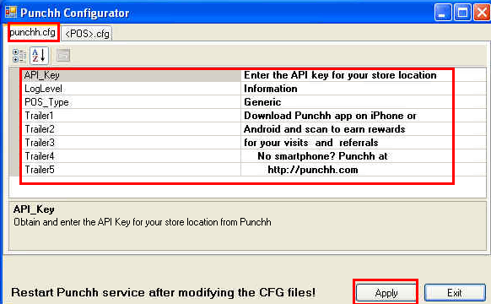

### Update the value for the API_Key parameter:

* Navigate to the Punchh Locations website (<https://punchh.com/locations>), log in, and find the API Key **specific for your location** as it is shown for the **MICROS** on the example below:

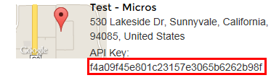

* Copy the API Key you just found
* On the on the **punchh.cfg** screen, select the **API_Key** parameter
* Enter your API Key into the “**Enter the API key for your store location**” field

### Update the LogLevel parameter

1. Introduction

The logging level can be customized. The following logging levels are available:

**\*NOTE:** Each next level includes all the levels above it.

* None – logging is completely suppressed
* System – logging service startup and shutdown messages
* Errors – logging errors only
* Warning - logging warnings and errors
* Information - logging information, warnings, and errors
* Request – logging HTTP Requests Sent
* Response – logging HTTP Responses Received

1. Customizing the logging level

To customize the logging level, please do the following:

* Select the **LogLevel** item, navigate to the LogLevel field, and open the drop-down list.
* Select an appropriate item from the list per the log level options explained above.

### Update the POS_Type parameter:

* Select the **POS_Type** item, navigate to the **Generic** field, and open the drop-down list.
* Select the **Micros** item from the list.
* Verify, that the **<POS>.cfg** tab is automatically renamed to the **Micros.cfg** name you just selected in the step above.

|  |
| --- |
| **\*NOTE:** Please do **NOT** hit the **Apply** button yet! |

## Setup Parameters on the *Micros.cfg* Screen

1. On the Punchh Configurator screen, select the **Micros.cfg** tab
2. On the **Micros.cfg** screen, update the following parameters shown on the screen below with appropriate data using drop-down menu options or direct typing:

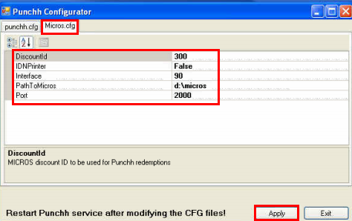

*NOTE: Hitting the Apply button will restart the Punchh service automatically.

### Update the DiscountId Parameter

Verify the **Update the DiscountId Parameter** section of this instruction and edit this parameter if needed.

### Update the IDNPrinter parameter

Verify the **Update the IDNPrinter parameter** section of this instruction and edit this parameter, if needed.

### Update the Interface parameter

Verify the **Update the Interface parameter** section of this instruction and edit this parameter, if needed.

### Update the PathToMicros parameter

Verify & Update a navigation path in the **PathToMicros** parameter

The value for the **PathToMicros** parameter must be pointed into the actual MICROS directory. By default, it comes with the “**d:\micros**” value. If you have installed the Micros in a different location (for instance, in the “**C:\Program Files\MICROS”** location), then you need to update the value with a path to your actual location (for instance, **“C:\Program Files\MICROS”)**

### Update the Port parameter

Please leave the default value such as “**2000**” as it is.

### Apply the Parameter Changes

On the **Punchh Configurator** screen, hit the **Apply** button. This step will close the Punchh Configurator screen, restart the **Punchh** service, and start to execute the defined configuration steps.

## Verify the Punchh Service setup

1. Verify that the Punch Configurator did start the Punch Service automatically:

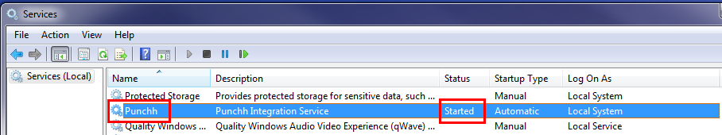

**\*NOTE:** You may want to set the following service recovery options as it is shown below (it is OPTIONAL):

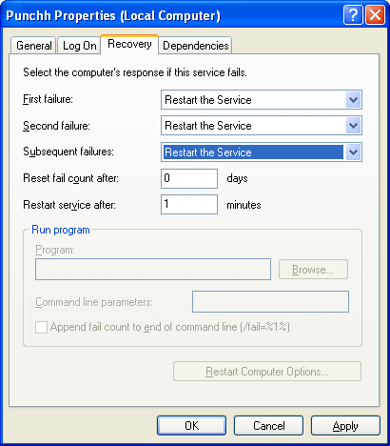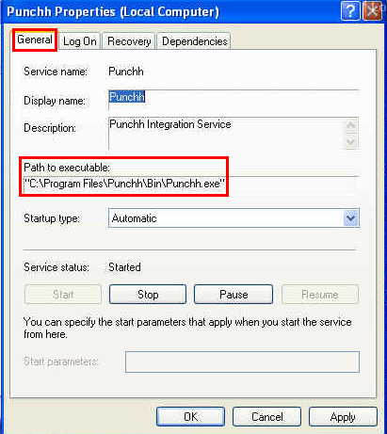

1. Verify that the Punchh Service has completed all the required steps successfully:
2. Navigate to the **%INSTALL DIR%\Logs** directory
3. Open the latest log file and scan for errors & warnings

* If there are no any issues related to the **pms90.isl** file, then the Punchh service reports this kind of information in the log file for each location shown above:

|  |
| --- |
| **4/25/2014 4:38:05 PM [Information]: Created or updated: D:\MICROS\Res\CAL\BPAD\FlashDisk\Micros\Etc\pms90.isl** |

* If the Punchh service finds the **pms90.isl** file already existing in any of the specified directories, then the Punchh service does NOT overwrite the existing **pms90.isl** file and reports such issues into a log file. For instance,

|  |
| --- |
| **4/25/2014 3:36:47 PM [Error]: File D:\MICROS\Res\CAL\WS4\Files\CF\Micros\ETC\pms90.isl doesn't seem to belong to Punchh. Please ensure we don't overwrite 3rd party files** |

1. Check the logs and make sure there are entries like that created every 5 minutes:

|  |
| --- |
| 4/25/2014 3:58:32 PM [Request]: [MICROS]: 0  4/25/2014 3:58:32 PM [Request]: ping-micros: pos_type=micros  4/25/2014 3:58:32 PM [Response]: ping-micros: 0  4/25/2014 3:58:32 PM [Response]: [MICROS]: 0 |

This is PING message from Micros, which confirms successful connection.

|  |
| --- |
| **\*NOTE:**   1. The Punchh service has to be restarted manually **every time after you manually edited the config files**.If you have NOT changed any values in the config files, then no need to restart the Punchh service. 2. When you are setting up the Punchh service, the Punchh Configurator restarts the service automatically, as needed. |

# Micros Application Integration with Punchh Service

## Micros Application Setup

**\*NOTE**: screenshots below maybe different depending on your version of the POS.

1. Verify if the MICROS Database is up and running.
2. Navigate to the **Micros Applications** menu and select the **Micros Control Panel** item:

 

1. If the Database is not running, then hit the **Front Of House** button and hit the **Reload DB** button to get the following status:



1. Verify that the Punchh service is running:



## Micros Application Configuration

### Login into the POS Configurator application:

* 1. Start the **POS Configurator** application: "C:\Program Files\MICROS\Res\Pos\Bin\poscfg.exe"
  2. Login: <Enter Your Login Credential> -> hit Enter



### Setup the Punchh interface record

* 1. On the POS Configurator screen, navigate to the **Interfaces** screen: **Devices** tab **-> Interfaces** button:

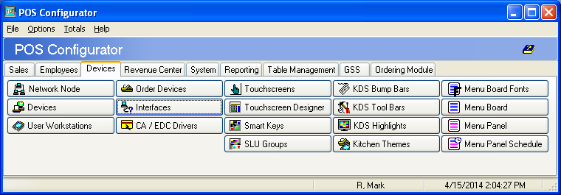

* 1. Navigate to the **Interfaces -> Record View** applet

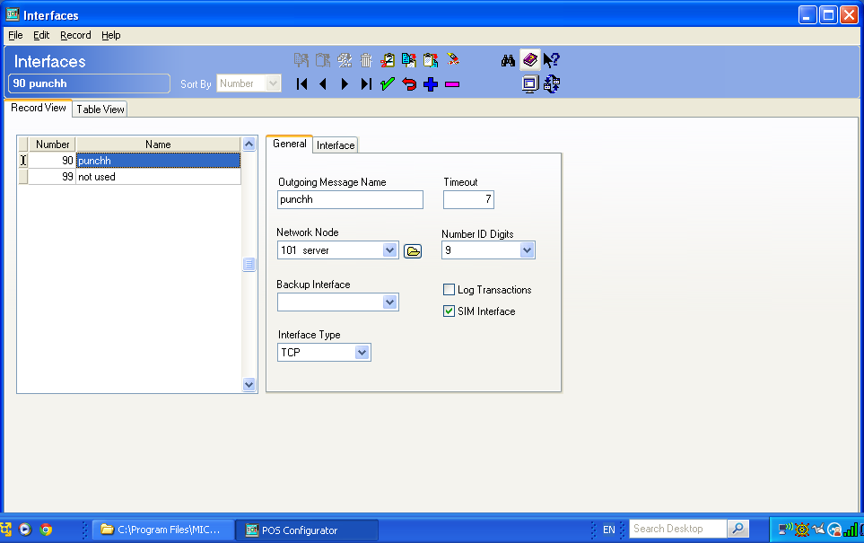

* 1. Create a new Interface record named “**punchh**” (it must be in a lower case)
  2. Navigate to the Number field of the new Punchh interface record and enter the number you defined at the The Interface parameter step
  3. Keep the new Punchh interface record selected on the **Record View** applet, navigate to the **General** applet under the **General** tab on the right, and enter data into the following fields:
* Outgoing Message Name: **punchh** (it must be in a low case)
* Timeout: **7**
* Network Node: **Select your particular MICROS server from the drop-down list**
* Number ID Digits: **9**
* Backup Interface: **leave it blank**
* Log Transactions check-box: **Unchecked**
* SIM Interface check-box: **Checked**
* Interface Type: **TCP**
  1. Save your entries - hit the **Save** button located on the Dashboard
  2. Navigate to the **Interface** applet under the **Interface** tab on the right, and enter data into the following fields:

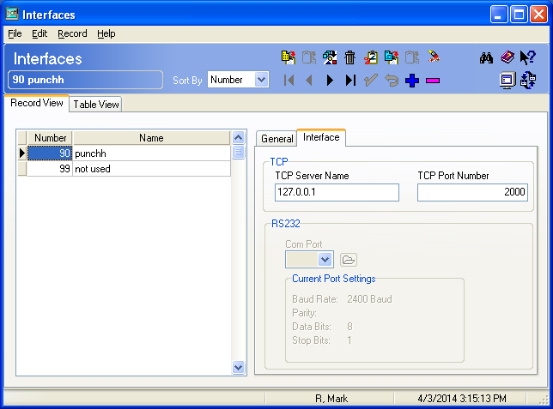

* TCP Server Name: **127.0.0.1** (your local server name)
* TCP Port Number: **2000** (it is a default value, keep it as it is)
  1. Save your entries - hit the **Save** button located on the Dashboard
  2. Close the Interfaces screen

1. Create check trailer named **Punchh** and enter the“**@@punch**” value like shown below:

**\*NOTE:** The “**@@punch**” is the placeholder for the Punchh barcode and message on the checks.

### Verify Discounts

1. On the POS Configurator screen, navigate to the **Discounts** screen: **Sales** tab **-> Discounts** button:

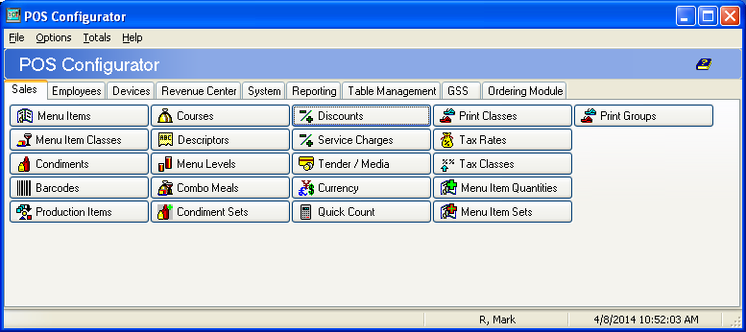

1. Navigate to the **Discounts** screen **-> Record View** applet

On the **Record View** applet verify that a discount record named “**punchh**” (it must be in a lower case) exists, and all the fields associated with this “punchh” discount contain the correct data as you defined at the **The DiscountId parameter** step.

### Setup Check Trailer on RVC Print Design

1. On the POS Configurator screen, navigate to the **RVC Print Design** screen: **Revenue Center** tab **-> RVC Print Design** button:

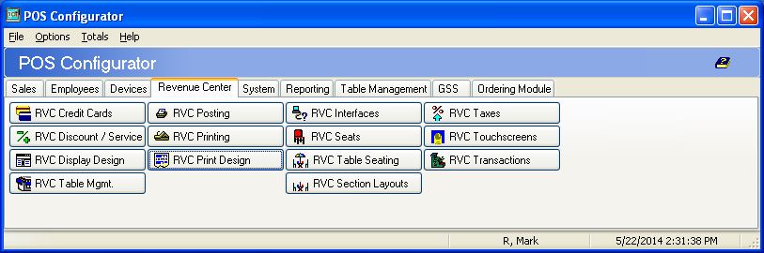

1. On the **RVC Print Design** screen, go to the **Record View** applet on the left and select any existing record
2. Navigate to the right applet and hit the **Trailers** tab
3. On the **Trailers** screen, hit the **Browse** button, and it will navigate to the **Descriptors** screen

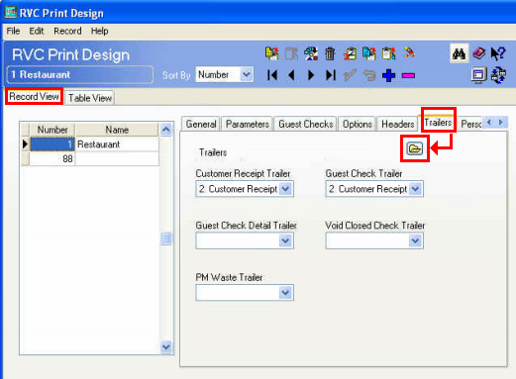

1. On the **Descriptors** screen, you have to be navigated to the **Trailers** screen. On the **Trailers** screen, go to the **Trailers Record View** applet on the left
2. On the **Trailers Record View** applet, find and select the record associated with the **customer** receipt
3. Keeping this record selected, navigate to the **Trailers Lines** applet on the right and enter the“**@@punch**” value like shown below **(**the “**@@punch**” is the placeholder for Punchh message on the checks):

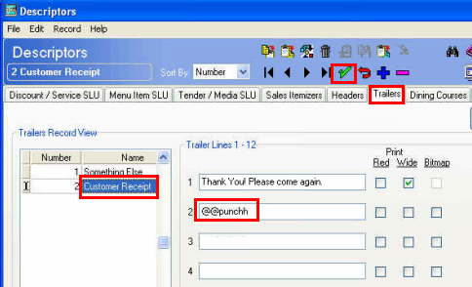

1. Save your entries - hit the **Save** button located on the Dashboard

### Create the Touchscreen button

As per the **Prerequisites** section, create the **Check-in** and **Redeem** buttons where the POS wants these buttons to be placed.

1. On the POS Configurator screen, navigate to the **Touchscreen Designer** screen: **Device** tab **-> Touchscreen Designer** button:

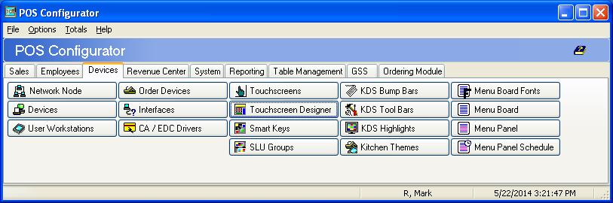

1. On the Touchscreen Designer screen, create the following buttons:

The **Check-In** button, with the parameters shown on the screenshot below:

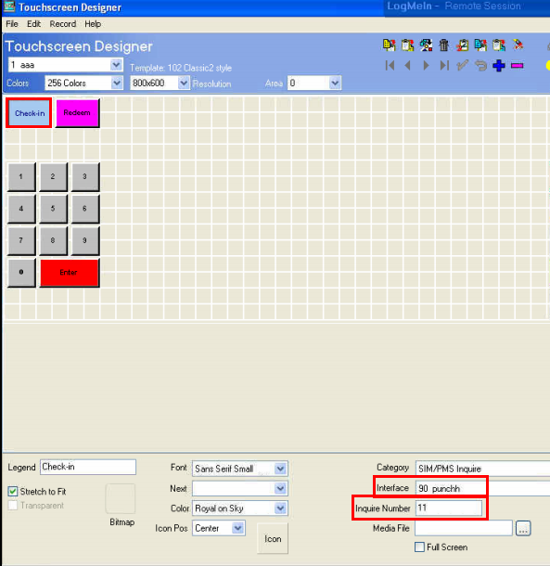

The Redeem button, with the parameters shown on the screenshot below:

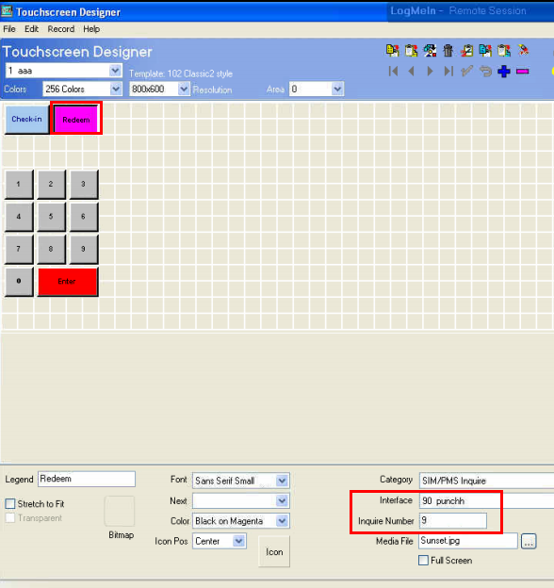

1. Save your entries - hit the **Save** button located on the Dashboard

### Reload the MICROS DB (or Reboot the system)



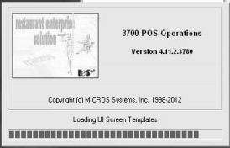

|  |
| --- |
| **The Punchh Integration Setup for the POS “MICROS” is complete!** |